MedDevDoc Marie Skłodowksa Curie Fellowship Programme 2024
CÚRAM, SFI Research Centre for Medical Devices
Ref. No. University of Galway 020-24

Applications are invited from suitable candidates for 25 full-time fixed term Marie Skłodowska-Curie Doctoral Fellows (DFs) with CÚRAM, SFI Research Centre for Medical Devices at University of Galway.

These positions are available from November 2024 for a period of 48 months.

MedDevDoc is an advanced Industry-Academia Training, Career Development, and Mobility Fellowship Programme.

CÚRAM MedDevDoc Fellowships are open to applicants of any nationality, resident anywhere in the world (see eligibility criteria in a guide for applicants), seeking a prestigious career development fellowship in medical device research and development based at one of the following host organisations: University of Galway (GALWAY), University College Dublin (UCD), The Royal College of Surgeons in Ireland (RCSI), Trinity College Dublin (TCD), University of Limerick (UL), Dublin City University (DCU), Technological University of the Shannon (TUS), University College Cork (UCC), National Institute for Bioprocessing Research and Training (NIBRT) and Technological University Dublin (TU Dublin).

Positions involve two main phases: an initial host organisation phase and a secondment phase in a non-academic sector. The projects will encompass the broad area of Medical Device Research and Development, including Biomaterials and Drug Delivery Devices, Machine Learning, Medical Imaging and Soft Robotics, Immuno Engineering, and Education and Public Engagement (EPE) and Science Advocacy Programmes and regulations.

During the 48-month MedDevDoc Programme, the University of Galway will publish a call for applications and recruit 25 Doctoral Students. To ensure a wide range of applicants from different genders, nationalities, and types of background education can engage with the programme. The target group for MedDevDoc is formed by Masters students interested in the key scientific areas of interest to CÚRAM including, Regenerative Medicine, Medical Devices (Biomaterials and Drug Delivery) and MedTech AI. All applicants must fulfil the requirements of the MSCA mobility conditions. Consequently, the dissemination will be internationally focused, use international media, and be in English. We welcome applications from candidates who have had career breaks and are looking to return to a research-based career and from candidates who have had a non-traditional career path.
You can learn more about our vision, research platforms, a consortium of academic and industry partners, Science policy and advocacy, and public engagement on our website CÚRAM - CÚRAM (curamdevices. ie). MedDevDoc fellows will collaborate and integrate with multidisciplinary teams to provide the training ground for designing and manufacturing next-generation devices and implants. Further information can be found in the Detailed Guide for Applicants to MedDevDoc and Quick Guide for Applicants to MedDevDoc are available at: https://curamdevices.ie/curam/research/meddevdoc/application-&-selection-process/.
This project has received co-funding from Horizon Europe’s Marie Skłodowska-Curie Actions, Grant Agreement No:101126640.

Essential Criteria:
As per the MSCA definition:
- MedDevDoc are open to candidates who have a 1st class or a 2:1 honour first degree and have/are due to obtain a Master’s in Biomaterials, Biomedical Engineering, Tissue Engineering, Cell Biology, Biology, Biochemistry, or related discipline from different genders and nationalities. They must not already own a doctoral degree. Medical Doctors are also invited to apply if they can demonstrate an understanding of the clinical or life sciences research process.
- All applicants for whom first language is not English must present an English language qualification taken within two years before the application (Suggested English language qualifications include IELTS, Cambridge C1 Advanced, Cambridge C2 Advanced, TOEFL iBT/TOEFL iBT Home Edition, Pearson PTE and Duolingo)
- Comply with the MSCA mobility rule: have not resided or carried out their main activity (work, studies, etc.) in Ireland for more than 12 months in the three years immediately before the submission deadline. Compulsory national service and short stays such as holidays are not considered.
Please note:
- MedDevDoc Fellowships are open to candidates of any nationality. Please see Employment Permits - University of Galway for further information.
- MedDevDoc welcomes applications from candidates with racial diversity, minority ethnic communities, women, disabilities, and Researchers at Risk. Please see: Guidelines for Inclusion of Researchers at Risk | Marie Skłodowska-Curie Actions (europa.eu), for further information.

Gross Salary:
Remuneration aligns with EC rules for Marie Skłodowska- Curie COFUND grants:
The minimum gross salary range for doctoral fellowships is from €30,901 to €37,726 per annum.

The range depends on the applicant's eligibility, such as Mobility and Family allowance. Salaries are subject to taxes and deductions, e.g., deduction of PRSI (employee social security) and income taxes. For more information about tax entitlements, please go to https://www.revenue.ie/

Start date: Positions are available from November 2024.

Continuing Professional Development/Training:

Fellows are encouraged to avail themselves of training and development opportunities to support their career development plans. Further, CÚRAM shall facilitate this training with its partners [For more details on our partners: CÚRAM - CÚRAM (curamdevices.ie)]. For information on moving to Ireland, please see www.euraxess.ie. Researchers are encouraged to engage with our Researcher Development Centre (RDC) upon employment - see HERE for further information. CÚRAM will also facilitate training along with its partners.

For information on moving to Ireland, please see www.euraxess.ie.

Equality, Diversity and Inclusion
The University of Galway is committed to principles of equality and encouraging diversity and inclusion. Several of the participating academic Institutions and Schools are holders of Athena SWAN awards. We celebrate the diversity of our staff and students and work to support an inclusive environment free from discrimination and harassment.

To Apply: The application process should include an Online application + Administrative Proposal: Part A plus Ethics Self-assessment form (including Max 2 Pages) + Part B (Research Proposal) + Academic CV (Max 3 pages with three references)
- Part A: Administrative Proposal: Max 1000 words: Part A plus Ethics Self-assessment form (including Max 2 Pages)
- Part B: The project summary (max. three pages) and a motivation letter (max. 1 page).
- Academic CV: Max 3 pages (With three references).

Candidates must develop a project proposal on CÚRAM relevant themes and submit it via the online application system. The system will remain open for applications until midnight (UTC) on the call deadline of 4th January 2024.

See the Detailed Guide for Applicants, Quick Guide for Applicants, and www.meddevdc.eu for more information.

For informal enquiries, contact the University of Galway programme manager at meddevdoc@Curamdevices.ie. Please put reference number University of Galway 020-24 in subject line of all queries related to this post.

The closing date for submission of application 1 is 15th April 2024 at 23.59 UTC.

We reserve the right to re-advertise or extend the closing date for this post.

The University of Galway is an equal opportunities employer.

All positions are recruited in line with Open, Transparent, Merit (OTM) and Competency-based Recruitment.

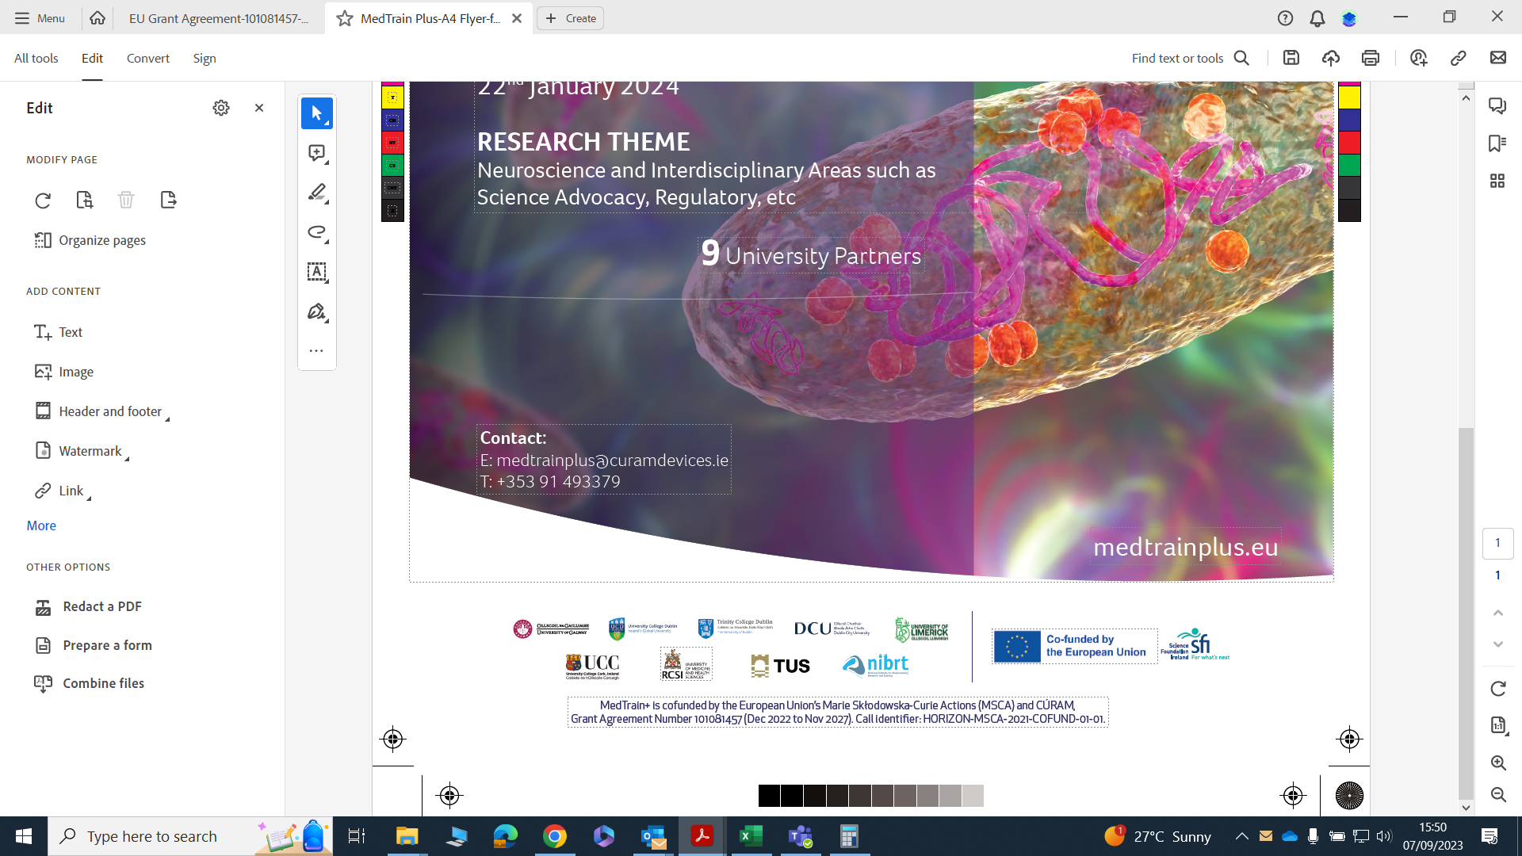
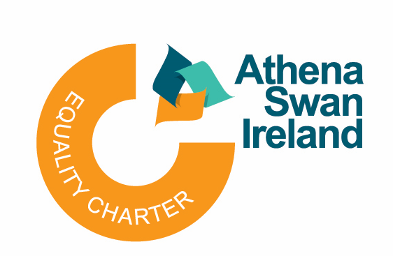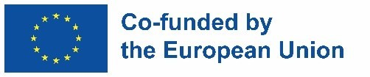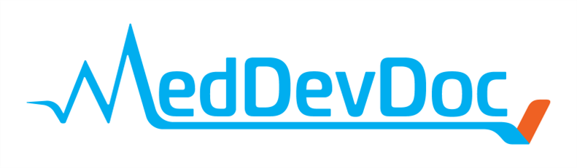

MedDevDoc is co-funded by the European Union’s Marie Skłodowska-Curie Actions (MSCA) and CÚRAM, Grant Agreement Number: 101126640 (Dec 2023 to Nov 2028). Call identiﬁer: HORIZON-MSCA-2021-COFUND-01-01.

